**JAVA**

1. **Difference between Arrays and ArrayList in Java?**

* Array is a part of core Java programming and has special syntax. ArrayList is part of the collection framework and implements List interface.
* Major difference is that; Array is a fixed length data structure, so we can change the length of Array one created, ArrayList is resizable.
* The other major one is that Array can contain both primitives and objects. ArrayList can only contain objects. It cannot contain primitive types.
* Also, we can compare Array and ArrayList on how to calculate length of Array or size of ArrayList. We use length for an

Array, we use size() method for an ArrayList.

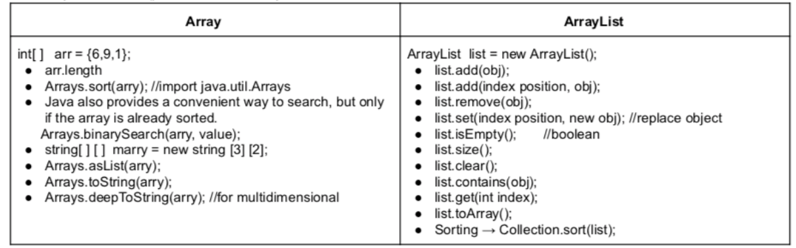

1. **What is thread safe or Synchronized?**

Thread safety is very important, and it is the process to make our program safe to use in multi-threaded environment. There are different ways through which we can make our program thread safe.

Synchronization is the easiest and most widely used tool for thread safety.

* JVM guarantees that synchronized code will be executed by only one thread at a time.
* JAVA keyword synchronized is used to create synchronized code and internally it uses locks on Object or Class to make sure only one thread is executing the synchronized code. Java synchronization works on locking and unlocking of the resource, so no thread enters into synchronized code.
* We can use synchronized keywords in two ways, one is to make a complete method synchronized and another way is to create a synchronized block.

1. **What's the difference between IS-A and HAS-A relationship?**

* IS-A is based on inheritance. This thing is a type of that thing
* **HAS-A rel**ationships are based on usage

Ex: class A HAS -A B if code in Class A has a reference to an instance of class B

public Horse{

private Halter myHalter;

public void jump(){

Sysout “im jumping”

You are calling a Halter instance variable to use the jump method that is coming from horse class. It means that Horse HAS-A Halter. Horse class has a Halter, because Horse declares an instance variable of type Halter. When code invokes tie() on the Horse object’s Halter instance variable.

**Selenium**

1. **How do you handle js alerts?**

If the alert on the browser comes from JavaScript, we use the Alert class.

Alert alert = driver.switchTo.alert();

alert.accept();

alert.dismiss();

alert.sendKeys();

alert.getText()

1. **How you handle browser pop ups?**

void dismiss() => clicks on the “Cancel” button as soon as the pop-up window appears.

void accept() => clicks on the “Ok” button as soon as the pop-up window appears.

String getText() => returns the text displayed on the alert box.

void sendKeys(String stringToSend) => enters the specified string pattern into the alert box.

1. **How to check the multiple selected values in dropdown?**

Select carsList = new Select(el)

carList.getSelectedOptions(): //returns the the selected options a list ( List<webelement>)

for each : carList.getSelectedOptions()

1. **How to use actions class?**

Actions class lets us do advanced mouse and keyboard operations: Control the mouse and Class that provides methods for advanced user interactions

* Hovering
* Scroll
* Double click
* Drag and drop
* Right click
* Mix/match operators

Actions action=new Actions(driver)

Action methods

* click()
* perform()
* hold()
* keydown()build()
* moveToElement(element)
* dragAndDrop(source,target).perform()
* sendKeys() different from the one we usually use

actions.moveToElement(source).clickAndHold().moveToElement(target).release().perform();

Actions won't work unless perform() is used

If you are chaining methods, you must use build() before perform()

1. **Cross Browser and Parallel Test**

SauceLab can be used for cross browser testing. We can also use testng.xml file for this purposes.

Basically, inside the suite there are 3 keys (name, thread count, parallel) and 2 different tests, one of them is for Chrome and the other one is for Firefox.

There is also parameter annotation and include name and value; name is browser and value is Chrome.

testng.xml:

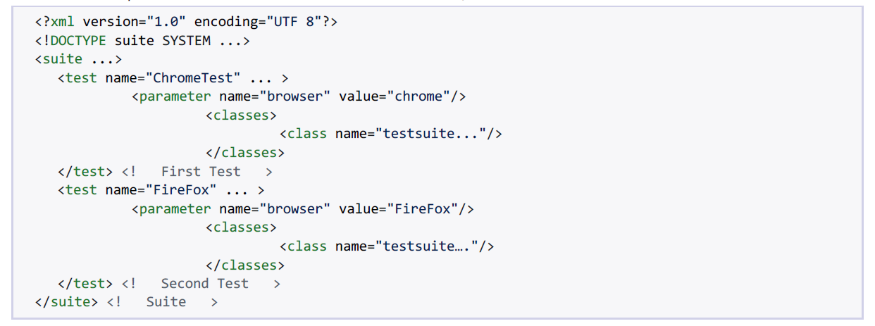

**SQL**

**Please explain what will be the output for the query below.**

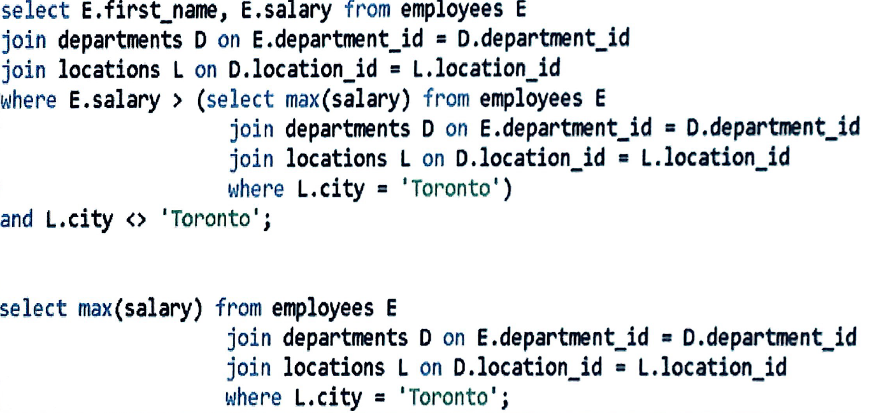

# 

# API

# What is API?

# API means connectivity. It is the messenger that takes requests and tells a system what you want to do and then returns the response back to you. API is the acronym for Application Programming Interface (which is software intermediary) that allows how applications talk with each other.

# API vs Webservices?

# API = browser: Selenium WebDriver, database: JDBC, MsOffice: Apache POI

# Webservices = if an API uses internet for communications, it is a Webservices. All Webservices are API.

# No UI (user interface) => web application with UI and we use Selenium Webdriver

# We use:

# SOAP → XML

# REST → JSON, XML, TEXT

# Postman, Rest Assured Library

# Name of some commonly used HTTP methods in REST based architecture?

# Create → POST (send data to the server)

# Read → GET (retrieves data from given server using a given URI)

# Update → PUT (Replaces all current representations of the target resource with the uploaded content)

# Delete → DELETE (Removes all current representations of the target resource given by a URI.)

# Authorization vs Authentication

# Authentication --> who are you

# Authorization --> what rights do you have

# Authentication is user and password

# Authorization has types:

# No Authorization

# Basic Authorization

# Bearer Token

# Inherit Auth from parent

# 

# JDBC

How can we connect db?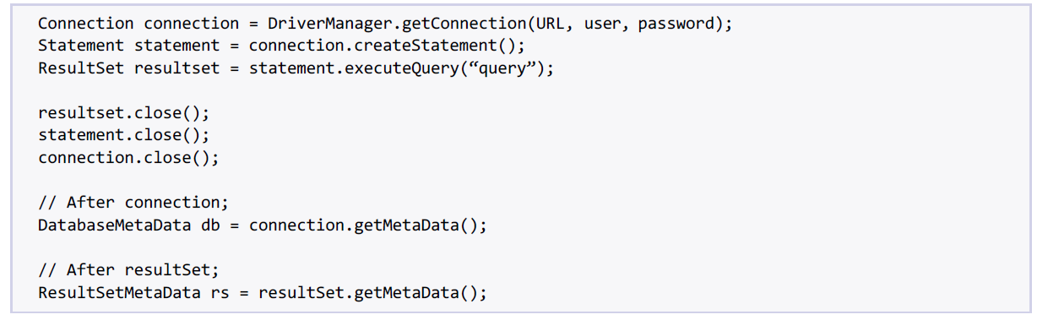

# 

# 

# Real Interview Questions

1. Tell me about yourself ?
2. Tell me about your current position ?
3. Tell me about your project ?
4. Tell me about your development team ?
5. How familiar are you with the front end development ?
6. How would your co workers describe you?
7. How do you plan your day ? your week ?
8. What are your career goals ?
9. Do you have any questions for me?
10. How do you rate yourself in terms of Cucumber ?
11. How do you rate yourself in terms of Java Skills ?
12. How do you rate yourself in terms of SQL ?
13. Did you write test plan ?
14. Did you write test cases ?
15. Did you build your framework or some build it ?
16. What are the prerequisites to building to this framework ?
17. How did you build from scratch ? Could you tell me about how you bring all the steps,tools together ? How did you do that ?
18. What is the feature file syntax in Cucumber?
19. What is your ideal scrum master ?
20. Why are you looking for a new opportunity ?
21. You mention cucumber,Junit,Jenkins etc. Who is helping you to set up all of the servers environment ? Are you doing that or ? Somebody helps you or doing it ?
22. What kind of repository do you use ?
23. How many QA people in your team ?
24. How do you do regression ?
25. How do you do smoke test ? What is your involvement to smoke test ?
26. Do you do Back-end testing ?
27. Do you do API testing ?
28. Do you test any mobile app ?
29. How do you get a report from Cucumber ?
30. Do you have experience performance and load test ?